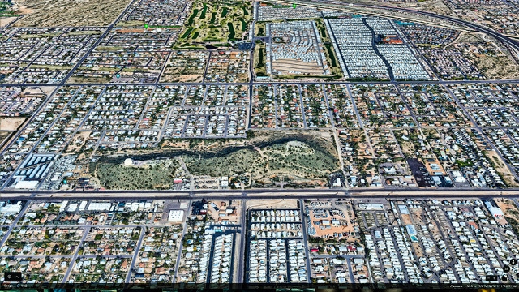
Twin Knolls Gone

STOP THE MINE OR WE GET THE SHAFT!!!

A PROPOSED MINING OPERATION IS SCHEDULED TO START IN DECEMBER AND WILL LEVEL OUR BEAUTIFUL TWIN KNOLLS, THE KNOLLS AROUND WHICH OUR NEIGHBORHOOD WAS BUILT.
And YES, THERE WILL BE BLASTING for 8-12 years.

- Are YOU willing to potentially lose your health due to increased truck and heavy equipment traffic and dust?
(Valley Fever, Covid-10, Cancers, Lung and Heart Issues)
- Are YOU willing to listen to blasting and heavy equipment noises 9 hours a day, 5 days a week for a decade?
(This is of special concern for anyone with PTSD issues)
- Are YOU willing to allow your home values to plummet? (Studies show -10% to -40%)
- Are YOU willing to allow the destruction of natural flora and fauna? (Saguaro are not protected when mining)
- Are YOU willing to allow the greed of one man and landscape company to destroy our peaceful neighborhood?
IF YOU ARE WILLING, DO NOTHING!

We hope you are not willing, because we need your help NOW!!! After fighting this battle for months, time is running out. The Air Quality Permit is scheduled to be approved in December and then mining will begin! We need more voices to speak up … your voice!!!! The state is not helping!! We MUST elevate to the EPA and to do that we MUST write our Members of Congress; McSally, Kelly, Sinema and Biggs asking them to have the EPA investigate this situation. Contact info and sample letters are at www.savetwinknolls.com.

PLEASE, IF YOU VALUE YOUR HOME, YOUR HEALTH AND YOUR LIFESTYLE, TAKE A COUPLE OF MINUTES TO CALL OR WRITE TODAY AND EVERYDAY.

Others to contact:
Maricopa Department of Air Quality 602-506-6010 AQMail@maricopa.gov
Steve Chucri - County Supervisor 602-506-7431 steve.chucri@maricopa.gov
Joy Rich - Maricopa County Manager 602-506-3415 countymanagersoffice@maricopa.gov
John Busterud - EPA Region 9 Administrator 415-947-4235 busterud.john@epa.gov
Gary Gold, Esq. - Policy Advisor to Kyrsten Sinema 202-819-6629 gary_gold@Sinema.Senate.gov

Tell them you do not want your health and community to be jeopardized. Current air quality rules are insufficient to safely allow for mining in the middle of a heavily populated neighborhood. Tell them the Twin Knolls air quality permit must be denied.

For more information on ways to help and to keep informed, go to our website noted above or to our Save Twin Knolls Facebook page. ALSO, watch for the Air Quality Public Hearing coming in November and be sure to attend!

Please consider donating at our GoFundMe link found on both web pages; we must obtain funds to secure legal representation so desperately needed. Any amount is welcomed!!

